A Falcon on the Beach
By Susan Heath

The other day I was doing a shorebird survey on the beach and I noticed something dark fly up from the passenger side of the truck. I was looking out the driver’s window focusing on the shorebirds along the water line and didn’t notice the dark bird that had been sitting on the sand. I’m guessing it didn’t notice me either or I wouldn’t have gotten so close to it!

I stopped and saw that it was a Peregrine Falcon. I must have spooked it off its breakfast because it was circling about 30 feet off the ground intent on getting back to the spot where it had been. I backed off and it landed, grabbed its prey, flew down the beach a bit, and landed again. I approached slowly and got some photos. I’ve seen lots of Peregrines perched up high on cell towers and out on small bay islands but I’ve never seen one sitting on the beach. It wasn’t until I got home and looked at the photos that I could tell the prey item was a Ruddy Turnstone, a chunky shorebird that spends a lot of time foraging along the beach.

Peregrine Falcons have been billed as the fastest bird on earth and indeed it has been calculated that they can reach speeds of 238 mph! Wow. Their average cruising speed is 24 to 33 mph. That’s more my speed but I wouldn’t want to be pursued by one of these birds. They usually begin their pursuit from above and then fold their wings and drop on their prey from above at incredible speeds. When a Peregrine Falcon grabs a bird from the air with their talons, they grab it with so much force, it looks like the bird exploded! They have been documented preying on 450 species of North American birds but their main prey is shorebirds, ducks, pigeons and songbirds.

The word peregrine means wanderer or pilgrim and Peregrine Falcons occur all over the world. In North America they breed in open landscapes with cliffs or skyscrapers for nest sites. They spend the winter on barrier islands, mudflats, and coastlines which is where we find them during winter in Texas. Their populations crashed in the 1950’s because of DDT poisoning, but they are now slowly recovering through extensive efforts to reestablish them at nest sites in the eastern U.S.

Peregrine Falcons are beautiful birds with graceful falcon flight and if you are lucky you might get to witness one zoom by along the beach or perched on a power pole. Look for the long wings and barred body with a strong mustache stripe down their cheek. Be careful not to confuse them with the smaller Merlin or American Kestrel (both beautiful falcons as well!).
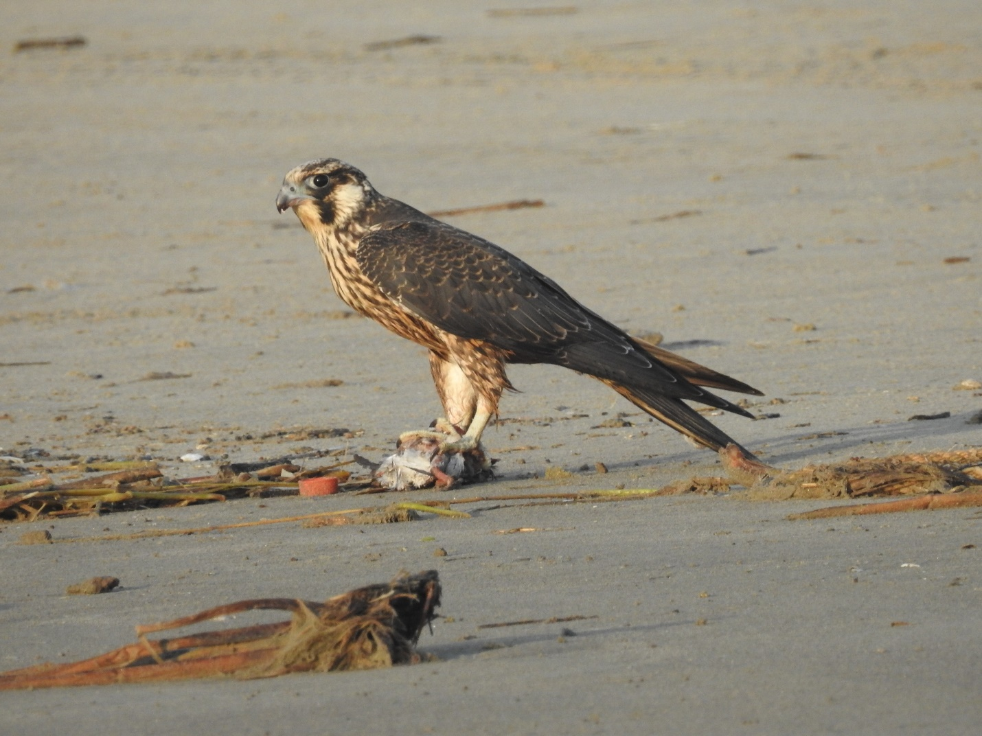

Photo by Sue Heath. Caption: Peregrine Falcon with captured Ruddy Turnstone.

