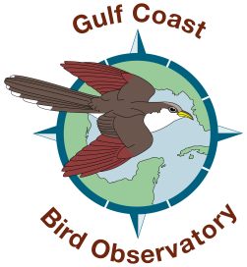
Tropical Forest Forever Fund
The GCBO Tropical Land Acquisition Grant Program

Grant Application Outline
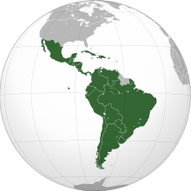
- What projects can be applied for?
Conservation land acquisition projects that focuses on buying native habitat for neotropical birds, threatened and endangered birds, and bird species of concern, that are located in Latin America.

- Who can apply?
Any proven non-profit NGO that operates in or with partners in Latin America can apply. Each organization will be background checked for previous work and projects completed, etc.

- How much do we grant annually?
Most projects can receive between $15,000 and $40,000 (USD). We normally only grant one project per year.

- What is the Grant Deadline?
We must receive your request by June 1st to be considered for funding in that calendar year.

- How do I apply?
Fill in the outlined form below or follow a similar format to apply.
Email the request to Martin Hagne at: mhagne@gcbo.org

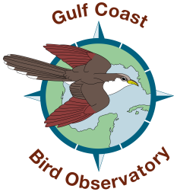
GCBO’s Tropical Forest Forever Fund

Grant Request Form

Organization(s) Applying: ______________________________________________________

Contact Person: ______________________________________________________________

Address: ____________________________________ City: ___________________________

State:_______________ Postal Code: __________ Country: _________________________

Name of Project: _____________________________________________________________

Location of Project: ___________________________________________________________

Coordinates of Projects: ____________________ _______________________

Acreage of Total Project: _____________ Date Funds are Needed: _____________________

Amount of Funds Requested: _______________________

Attach the following information:

- Proof of Organization’s Non-Profit Status
- Mission and Description of the Organization
- Detailed Description of the Project
- List of Neotropical Bird Species using the Project Site
- List of Other Bird Species of Concern or Focus
- Budget of the Project
- Funding Secured So Far

Email request to Martin Hagne at: mhagne@gcbo.org

